

FAMILY PRACTICE
Armada Road, Whitchurch, BRISTOL BS14 0SU. TEL: 01275 832285
GP Partners; Dr K Jones & Dr I Da Costa & Dr J Frawley,
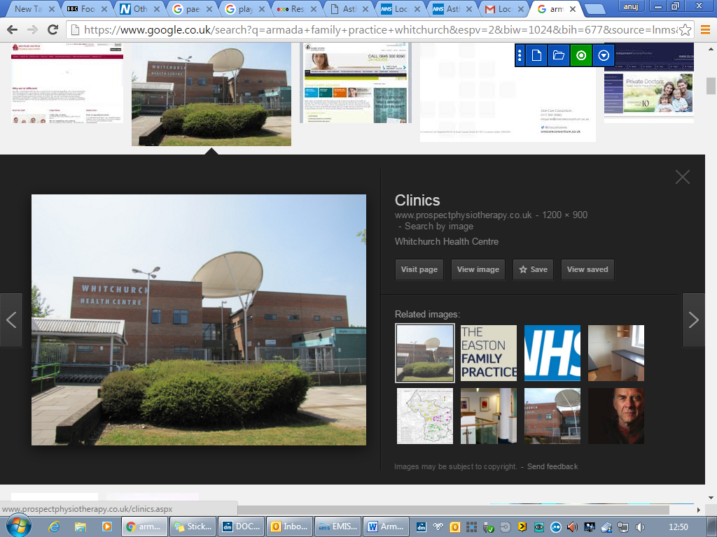
Great opportunity to join a friendly and supportive practice

Salaried GP vacancy, 4-8 sessions pw

The Armada Family Practice works from a modern purpose-built health centre with a practice population of circa 16,300 patients. We are part of Swift Primary Care Network who cover approximately 80,000 patients across South Bristol.

We are a friendly practice, with a large clinical and non-clinical support team. We are progressive and innovative in our approach to general practice and are happy to discuss new ways of working. Our vision is to achieve excellent patient care, led with compassion and a patient-centred approach.

The practice has a diverse team of GPs, Advanced Practitioners, Paramedic practitioners, Practice Nurses, HCAs, Pharmacists, MSK specialist, Dementia Nurses & Health and Wellbeing coaches and is supported by a PCN mental health nurse and Social prescriber.
We support a number of care homes in our practice area and our GPs undertake weekly ward rounds to ensure patients are receiving appropriate support.

All our appointments are booked by our experienced care navigation team who ensure that patients are booked in with the right clinicians to help the patient. They use a navigation tool called Sentiers which has been adapted to meet our needs, and our appointment system.

We can offer:

- Competitive salary.
- Annual leave entitlement of 6 weeks + 1 weeks study leave + bank holidays (pro rata)
- On call team of three clinicians per day, so you are never on your own.
- Compact practice area with ample parking and covered bike storage
- Training Practice
- Monthly practice meetings – you can help shape the practice
- Daily get together over coffee
- Home visits are generally within a five minute drive/cycle
- EMIS Web clinical system
- CQC rated “Good”
- Future Partnership opportunities
- Staff health and wellbeing coaches/workshops

If you wish to discuss the position further or to arrange an informal visit, please do not hesitate to contact Mrs Victoria Fyfe at the Armada Family Practice Victoria.fyfe1@nhs.net
Further practice information is available from our website: www.armadapractice.co.uk

If you wish to apply for this position, please submit a current CV and covering letter to Victoria.fyfe1@nhs.net

